**CLINKER COOLER**

**Grate Cooler Process Terminology**

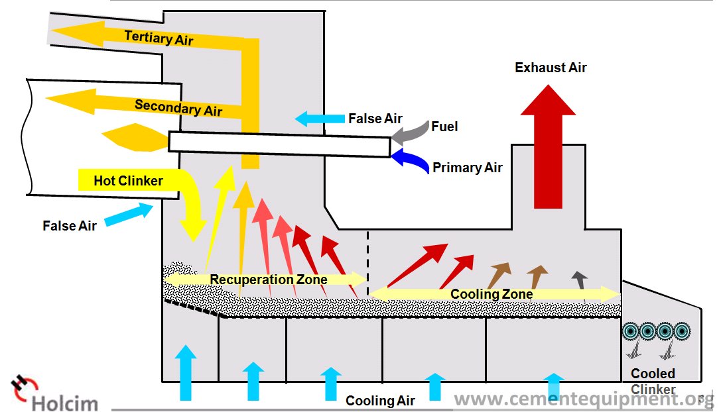

**Grate Cooler Equipment Terminology**

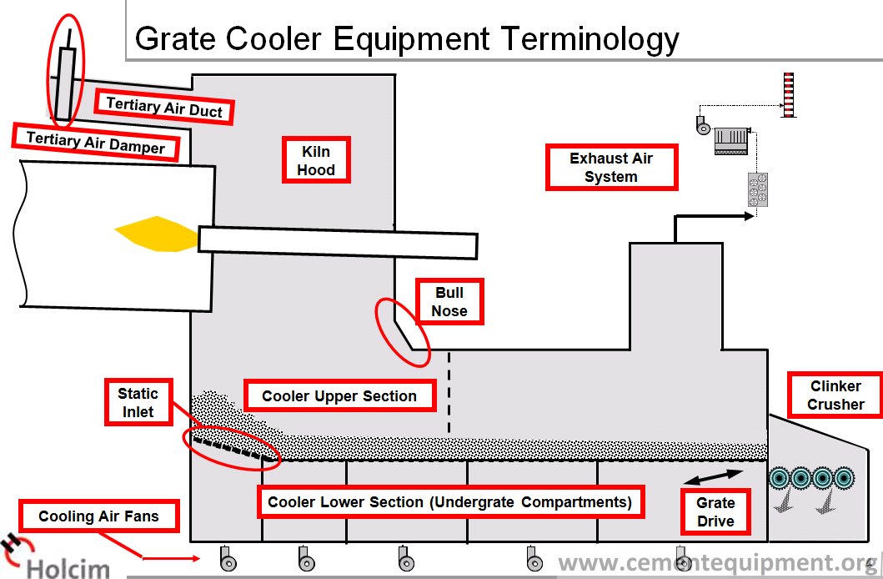

**Grate Assembly**

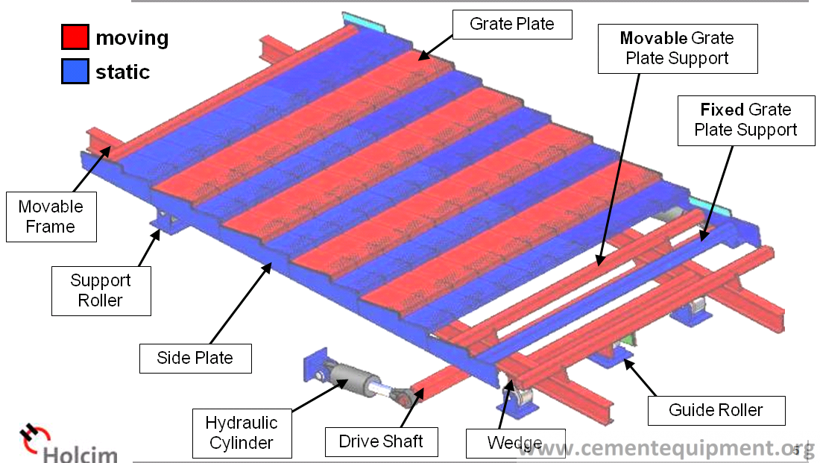

**Durability of concrete made from cement** is certainly determined by the **clinker quality** and **composition**. The clinker must be combined to a **low residual free lime (<2.5%)** and **not contain more than 5% MgO**. However, presuming adequate combination, the strength development of the cement made from the clinker is the primary measure of clinker quality.

The strength development of cement, and concrete made from cement, is determined by the silicate content of the cement in the minerals C3S and C2S.

 The Fuller cooler develops a fast initial cooling of the clinker; this fact is of great importance for the forma­ tion of tricalcium silicate(Ca3S). This cooler allows for clinker input temperatures of about 1360- 1400 o C, which increases the  thermal  efficiency  up  to  72- 75 %. The application of excess cooling air results in cooling of the clinker down to 65 °C; this tempera­ture allows an immediate  grinding of the clinker to finished cement.

Clinker cooling is necessary because:

* Hot clinker is difficult to convey
* Hot clinker has a negative effect on the grinding Process.
* The reclaimed heat content of the hot clinker of about 200 kcal/kg, is an important factor lowering the production cost.
* Proper  cooling   improves   the   quality   of   the cement.

**Speed of clinker cooling**

* The speed of clinker cooling influences the **ratio between the content of crystalline and liquid phases in the clinker**.
* **During slow cooling, crystals of almost all clinker components are formed, whereas fast cool­ ing hampers formation of crystals, causing part of the liquid phase to solidify as glass**.
* fast cool­ing prevents growth of crystals. The proportion of liquid phase in clinkers from rotary kilns is in the range from 20- 25 %.
* Fast clinker cooling influences especially the behav­ior of the MgO, and therefore also the soundness of the resulting cement.

**Cooling and resistance to chemical attack**

* Rapid clinker cooling also increases the sulfate resist­ance (sodium and magnesium sulfate) of the cement.
* This is explained by the fact that the C3A-content, which is related to the resistance of Portland cement to attack by sulfate solutions, is mainly present in aglassy state, when cooled rapidly; in this form the C3A is much less susceptible to attack by sodium or magnesium sulfate.
* Fig. 21.1. shows the expansion of two mortar rods, made from the same clinker containing 11 % C3A, and stored in a 5 % solution of magnesium sulfate. In one case- applying slow cooling- the C3A crystal­ lized completely, whereas in the other case the clinker was cooled rapidly [263]. The curves show the definite advantage of rapid clinker cooling.

**Solution:**

1st rule:

**Keep the clinker on the grates = minimize clinker fall through**

**improve gap management**

Cooler grate plates are designed to carry the hot clinker bed and are made of heat-resistant steel.

The rest of the cooler is not designed for such high temperatures; particularly the supporting structure beneath the grate must not be exposed to more than 200°C.

Hot clinker must be prevented from spilling through the grate by keeping all functional gaps tight (gap management).

2nd rule:

**Controlled air distribution into the clinker**  
**minimize air losses  
compartment sealing required.**

Cooling air must follow the intended channels and cool the intended areas.

This cannot be achieved if the cooler leaks air through worn plates, gaps, poor compartment seals, or leaking hopper discharge valves.

Also, intake of false air through the kiln outlet seal, clinker crusher, or cooler exhaust-air system must be minimized.

Unsealed compartments

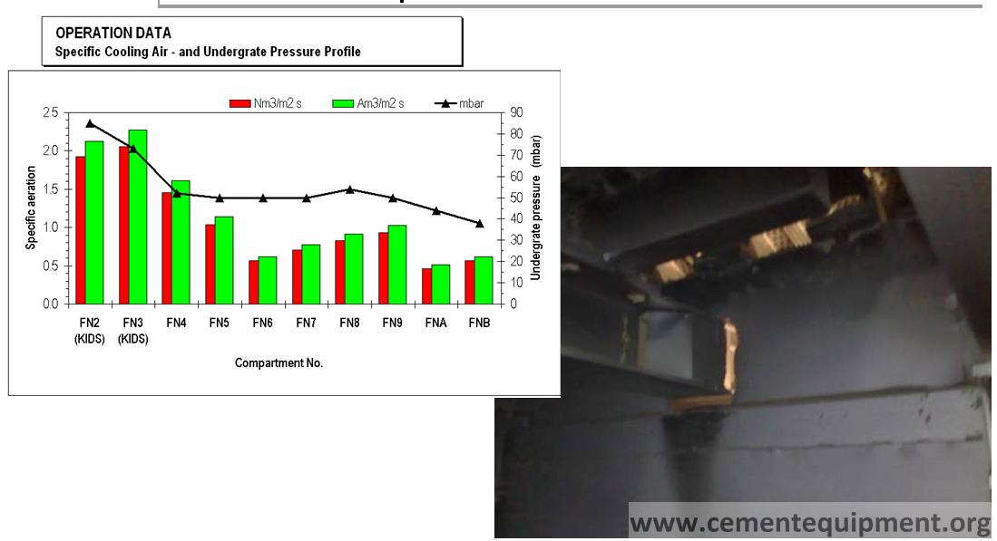

3rd rule:

**Operate with high clinker bed  
low grate speed  
increased heat recuperation**

A high clinker bed increases the residence time of the air in the clinker, essential for good heat exchange.

The cooler should always be operated at the lowest possible grate speed.

**Calculation of Cooling Time – Retention Time**

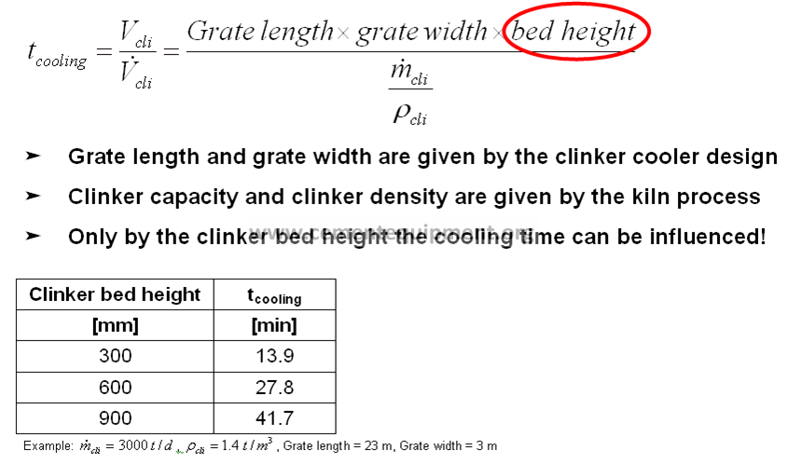

**Keeping the Clinker on the Grate is the Key**

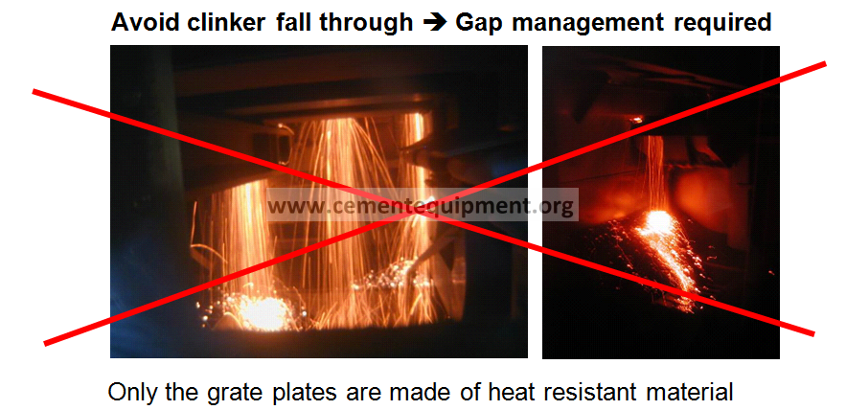

**Gap Management**

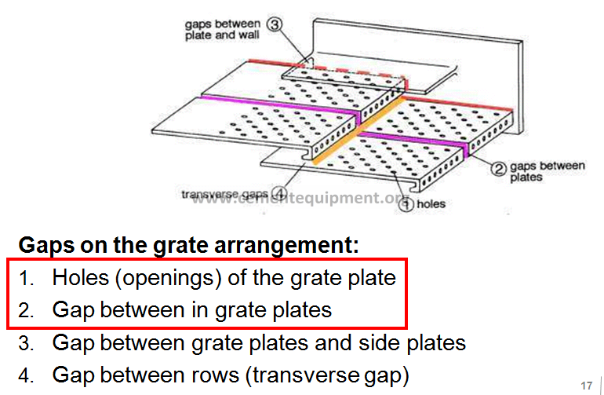

**Overview Grate Plates: Air openings**

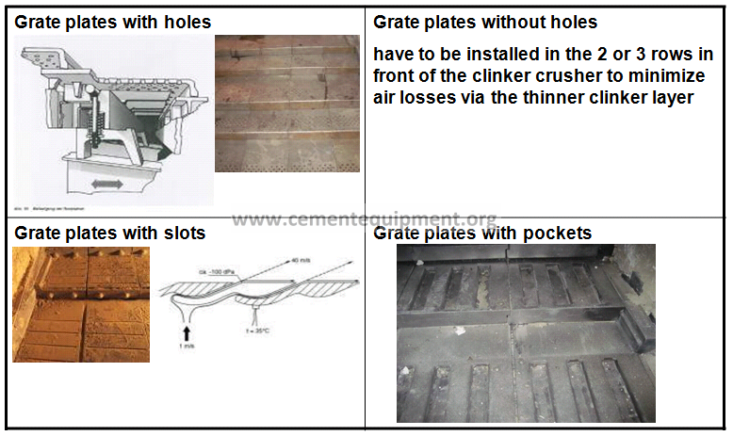

**Targets for gaps on the grate arrangement**

* Gap between the grate plates: max. 2 mm
* Gap between fixed and movable row: 1 mm
* Gap between movable and fixed row: 3 mm
* Side gap:-5 to 7 mm if side plates are fixed on side walls

-2 mm on movable rows if side plates are fixed on the fixed grate plate supports (0 mm in the area of the fixed grate plates supports)

* Grate guidance: 0.25 mm on each side of the guide roller  
  (Max 1 mm in total)

**Criteria for Static inlet**

* Adequate number of air cannons required.(vessel size min. 100 liter; nozzles required)
* Installed specific aeration min. 1.8 m3/m2/s.
* **Static pressure of the fans min. of 100 mbar under grate pressure**.
* Downwards **slopped grate plate (5° to 8°) to create downhill force for big lumps**
* Static (dead) clinker layer on the grate plates before start-up
* **Burn tip position: 500 to 1000 inside cold kiln**
* **Clinker drop height: > 4 meter**
* **Sufficient air required already during start-up**

**Clinker Bed Height**

* Increased clinker bed height  
  > increased retention time of air and clinker  
  > increased cooling time  
  > improved heat transfer  
  > improved clinker cooling
* 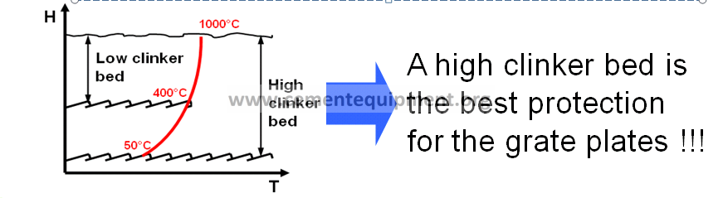

**Air Distribution: Clinker Temperature Profiles**

**Hot clinker at the cooler inlet and at the border sides  
= high pressure resistance.**

**Cold clinker at the cooler outlet and in the centre of the grate  
= low pressure resistance.**

The cooling air escapes in aeras of low pressure resistance.

> Small aeration field in the recuperation zone and a good chamber sealing is required !!!

**Target:Minimize cooling air losses to cold clinker area**

* False Air Minimization
  + At cooler exhaust air system
  + Kiln nose ring cooling
  + Kiln inlet and out seal
  + Doors, inspection windows

**Target: Reduce cold air intake**

**Devices/system:**

[**https://www.vega.com/en-us/industries/cement-industry/clinker-cooler**](https://www.vega.com/en-us/industries/cement-industry/clinker-cooler)

<https://www.mirion.com/products/clinker-coolers-cameras>

<https://www.sick.com/in/en/industries/building-materials/cement/pyro-process/clinker-cooler/monitoring-the-fan-speed/c/p510991>

**Process Description-**[**http://www.chaeng.co/product/grate-cooler.html**](http://www.chaeng.co/product/grate-cooler.html)

Grate cooler machine of CHAENG, adopts the new efficient grid plate structure which with very few leakage occurring, less abrasion and longer service life.

The grate cooler is the main equipment in calcining system of the cement plant. Its main function is to cool and transport the cement clinker. It also provides hot air for rotary kiln and decomposing furnace, and it is the main equipment for heat recovery in calcining system.

Grate [cooler](http://www.chaeng.co/product/cooler.html) of CHAENG is new energy-saving clinker cooling equipment, which adopts international advanced flow-control technology, makes continuous optimization and development relying on advanced thermal technology. Its output can be improved by 20% compared with traditional grate cooler. Heat consumption can be saved more than 10%.

